Line in Space

Definition
# Source: AI Source: Provided by: [Data Path: Persons Table -> ID Column: 1, Name_En Column: Motasem Essam] -> From: [ChatGPT] on [7/25/2026]
A line in space is an infinitely extending, straight, one-dimensional geometric object that exists in three-dimensional space.
Unlike a line in plane geometry, which is restricted to a two-dimensional plane, a line in space can have any orientation in three dimensions. It is uniquely determined by a point on the line and a nonzero direction vector.
A line in space can be represented parametrically as
$$r=a+td, t∈R$$
where:
- $r$ is the position vector of a general point on the line.
- $a$ is the position vector of a fixed point on the line.
- $d$ is a nonzero direction vector.
- $t$ is any real number.

Simple Definition
# Source: AI Source: Provided by: [Data Path: Persons Table -> ID Column: 1, Name_En Column: Motasem Essam] -> From: [ChatGPT] on [7/25/2026]
A line in space is a straight path that extends infinitely in both directions within three-dimensional space.
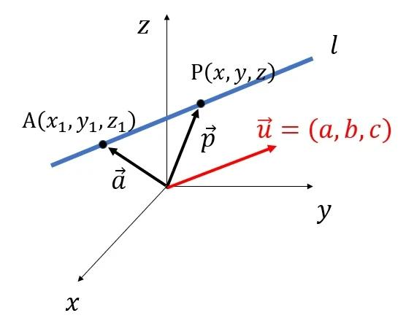
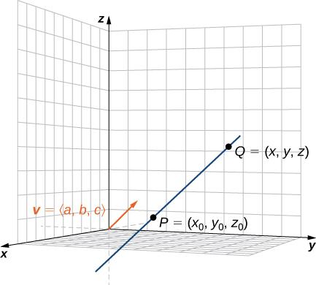
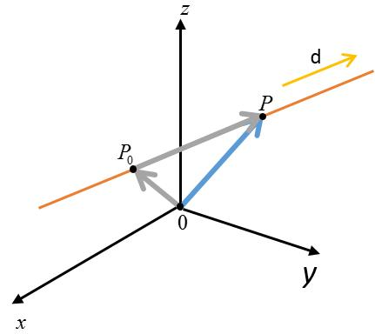
Examples include an idealized straight line passing through two points in a room or a line extending through the three-dimensional coordinate system.

Key Characteristics
# Source: AI Source: Provided by: [Data Path: Persons Table -> ID Column: 1, Name_En Column: Motasem Essam] -> From: [ChatGPT] on [7/25/2026]
- One-dimensional: A line has length but no thickness.
- Infinite extent: It extends without end in both directions.
- Straight: Its direction remains constant.
- Three-dimensional position: It can be described using three coordinates.
- Defined by a point and direction: One point and a nonzero direction vector uniquely determine a line.
- Infinitely many points: Every real value of its parameter corresponds to a point on the line.
- May or may not lie in a particular plane: Every line in Euclidean three-dimensional space lies in at least one plane, but it is not restricted to the coordinate planes.

Types of Lines in Space

1. Coordinate-Axis Line
# Source: AI Source: Provided by: [Data Path: Persons Table -> ID Column: 1, Name_En Column: Motasem Essam] -> From: [ChatGPT] on [7/25/2026]
A coordinate-axis line coincides with one of the three principal axes of the Cartesian coordinate system.
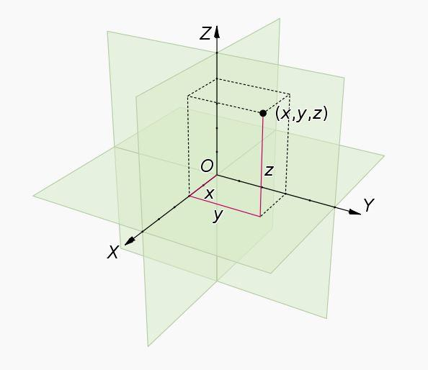
The three coordinate axes are:
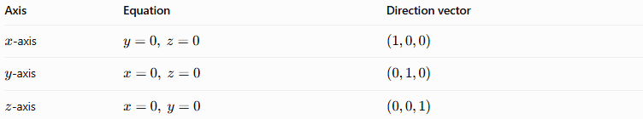
Axis | Equation | Direction vector
$x$-axis | $$y=0, z=0$$ | $$\left(1,0,0\right)$$
$y$-axis | $$x=0, z=0$$ | $$\left(0,1,0\right)$$
$z$-axis | $$x=0, y=0$$ | $$\left(0,0,1\right)$$
All three axes pass through the origin $O\left(0,0,0\right)$ and are mutually perpendicular.

2. Line Parallel to a Coordinate Axis
# Source: AI Source: Provided by: [Data Path: Persons Table -> ID Column: 1, Name_En Column: Motasem Essam] -> From: [ChatGPT] on [7/25/2026]
A line parallel to a coordinate axis has the same direction as that axis, but it does not necessarily pass through the origin.
For example, the line
$$\left(x,y,z\right)=\left(t,2,3\right), t∈R$$
is parallel to the $x$-axis because $y=2$ and $z=3$ remain constant while $x$ varies.
Similarly:
- A line parallel to the $y$-axis has constant $x$ and $z$.
- A line parallel to the $z$-axis has constant $x$ and $y$.

3. Line Through Two Points in Space
# Source: AI Source: Provided by: [Data Path: Persons Table -> ID Column: 1, Name_En Column: Motasem Essam] -> From: [ChatGPT] on [7/25/2026]
Any two distinct points in three-dimensional space determine exactly one straight line.
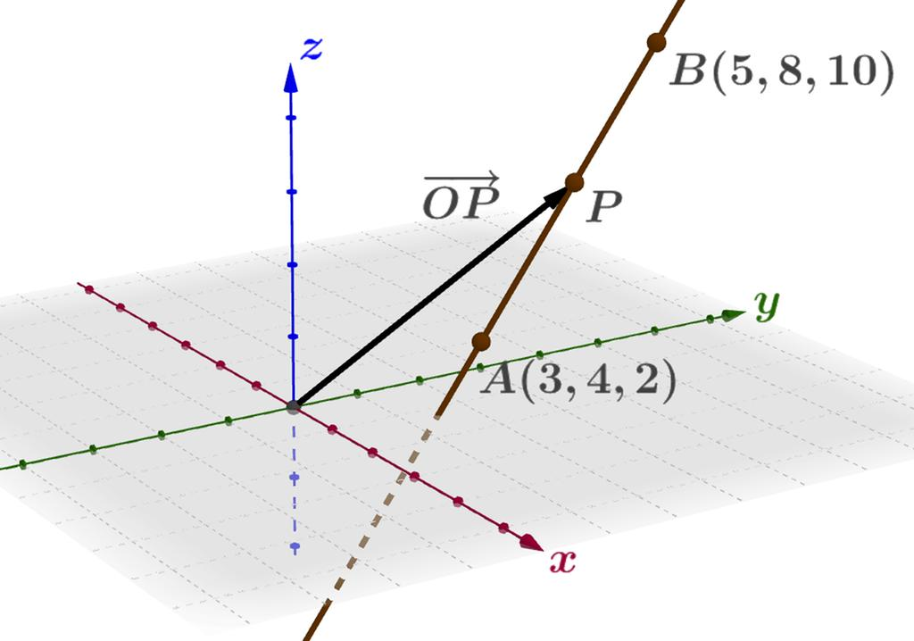
Let
$$A\left(x_{1},y_{1},z_{1}\right), B\left(x_{2},y_{2},z_{2}\right)$$
The direction vector of the line is
$$d=B-A=\left(x_{2}-x_{1}, y_{2}-y_{1}, z_{2}-z_{1}\right)$$
The line can then be represented as
$$r=A+t\left(B-A\right), t∈R$$
The condition $A≠B$ is essential because two coincident points do not determine a unique direction.

4. Line with a General Spatial Direction
# Source: AI Source: Provided by: [Data Path: Persons Table -> ID Column: 1, Name_En Column: Motasem Essam] -> From: [ChatGPT] on [7/25/2026]
A general spatial line may be oriented diagonally through all three coordinate directions.
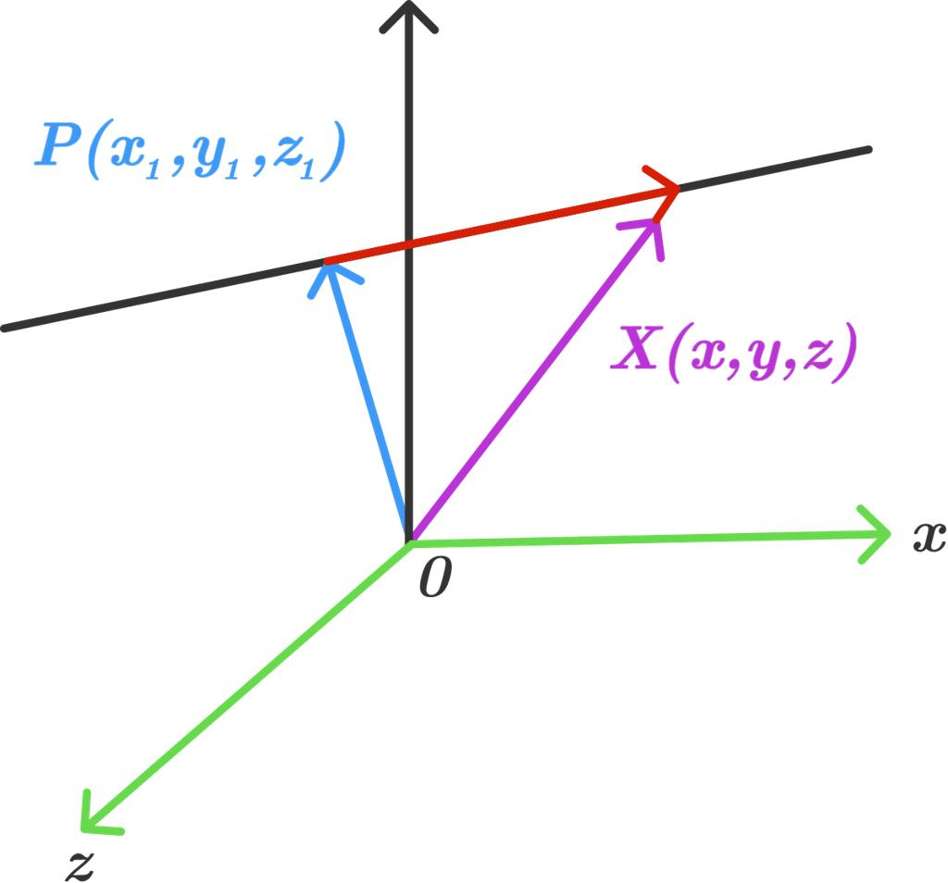
For example,
$$\left(x,y,z\right)=\left(1,2,3\right)+t\left(2,-1,4\right)$$
describes a line passing through $\left(1,2,3\right)$ with direction vector $\left(2,-1,4\right)$.
Its parametric equations are
$$\begin{aligned}x&=1+2t \\ y&=2-t \\ z&=3+4t\end{aligned}$$
As $t$ varies over all real numbers, the point moves along the entire line.

5. Line Defined by a Vector Equation
# Source: AI Source: Provided by: [Data Path: Persons Table -> ID Column: 1, Name_En Column: Motasem Essam] -> From: [ChatGPT] on [7/25/2026]
A line can be described compactly using vectors.
The vector equation is
$$r=a+td$$
For example, if
$$a=\left(2,1,0\right), d=\left(1,3,2\right)$$
then
$$r=\left(2,1,0\right)+t\left(1,3,2\right)$$
This form is especially useful when studying intersections between lines and planes or comparing the directions of two lines.

Mathematical Representations of a Line in Space

1. Parametric form
# Source: AI Source: Provided by: [Data Path: Persons Table -> ID Column: 1, Name_En Column: Motasem Essam] -> From: [ChatGPT] on [7/25/2026]
For a line through $P_{0}\left(x_{0},y_{0},z_{0}\right)$ with direction vector $\left(a,b,c\right)≠\left(0,0,0\right)$:
$$\begin{aligned}x&=x_{0}+at \\ y&=y_{0}+bt t∈R \\ z&=z_{0}+ct\end{aligned}$$

2. Symmetric form
# Source: AI Source: Provided by: [Data Path: Persons Table -> ID Column: 1, Name_En Column: Motasem Essam] -> From: [ChatGPT] on [7/25/2026]
When $a$, $b$, and $c$ are all nonzero, the parametric equations can be written as
$$\frac{x-x_{0}}{a}=\frac{y-y_{0}}{b}=\frac{z-z_{0}}{c}$$
If any direction component is zero, the corresponding coordinate remains constant, and that coordinate must be written separately rather than divided by zero.

3. Line through two points
# Source: AI Source: Provided by: [Data Path: Persons Table -> ID Column: 1, Name_En Column: Motasem Essam] -> From: [ChatGPT] on [7/25/2026]
Given distinct points $A$ and $B$:
$$r=\left(x_{1},y_{1},z_{1}\right)+t\left(x_{2}-x_{1},y_{2}-y_{1},z_{2}-z_{1}\right)$$
where $t$ ranges over all real numbers.

Worked Examples
# Source: AI Source: Provided by: [Data Path: Persons Table -> ID Column: 1, Name_En Column: Motasem Essam] -> From: [ChatGPT] on [7/25/2026]
Example 1: Finding a point on a line
Consider
$$\left(x,y,z\right)=\left(1,2,3\right)+t\left(2,1,-1\right)$$
Find the point corresponding to $t=2$.
Substitute $t=2$:
$$\begin{aligned}x&=1+2\left(2\right)=5 \\ y&=2+2=4 \\ z&=3-2=1\end{aligned}$$
Answer: The point is $P\left(5,4,1\right)$.
Example 2: Finding the direction vector
Given
$$A\left(1,2,3\right), B\left(4,6,5\right)$$
The direction vector is
$$d=B-A=\left(3,4,2\right)$$
Therefore, the line through $A$ and $B$ is
$$r=\left(1,2,3\right)+t\left(3,4,2\right)$$
Example 3: Checking whether a point lies on a line
Consider the line
$$\left(x,y,z\right)=\left(1,2,3\right)+t\left(2,1,1\right)$$
Determine whether $Q\left(5,4,5\right)$ lies on it.
From the $x$-coordinate:
$$1+2t=5⟹t=2$$
Using $t=2$, the other coordinates become
$$y=2+2=4, z=3+2=5$$
Both match the point's coordinates.
Answer: $Q\left(5,4,5\right)$ lies on the line.

Relationships Between Lines in Space
# Source: AI Source: Provided by: [Data Path: Persons Table -> ID Column: 1, Name_En Column: Motasem Essam] -> From: [ChatGPT] on [7/25/2026]
Two distinct lines in three-dimensional space can have several relationships.
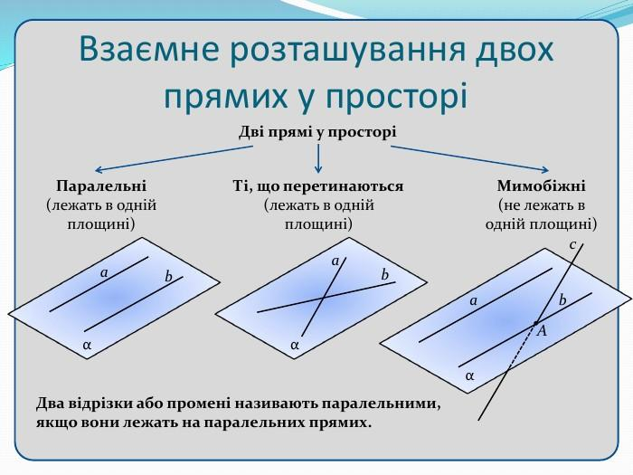
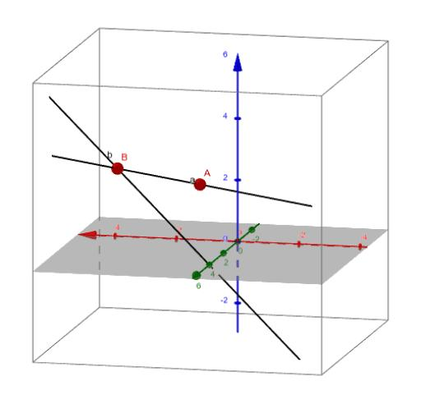
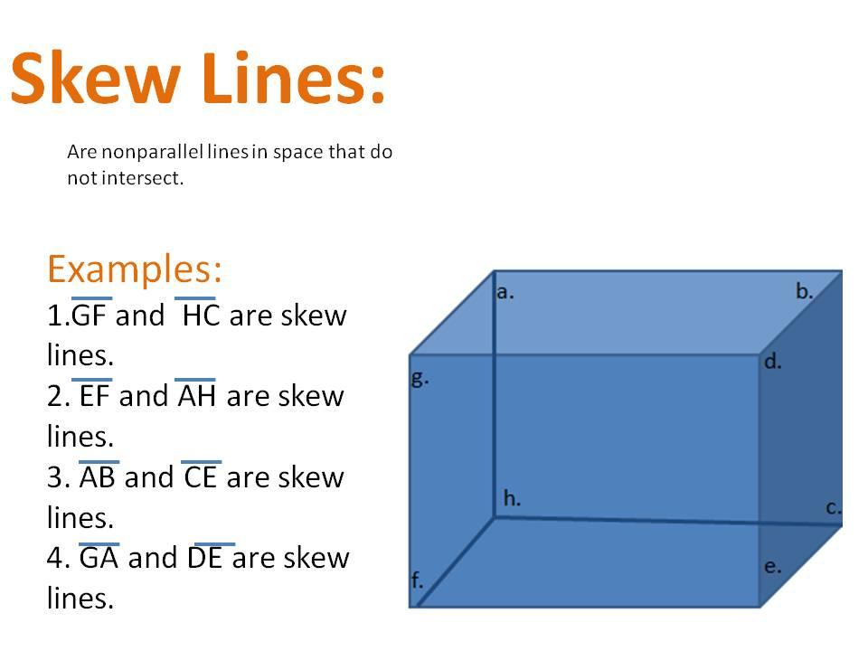
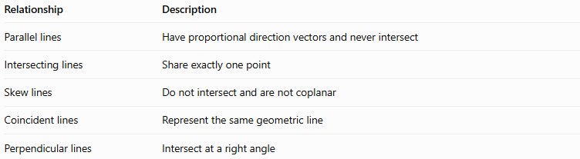
Relationship | Description
Parallel lines | Have proportional direction vectors and never intersect
Intersecting lines | Share exactly one point
Skew lines | Do not intersect and are not coplanar
Coincident lines | Represent the same geometric line
Perpendicular lines | Intersect at a right angle
Two perpendicular lines must intersect; skew lines cannot be perpendicular in the usual geometric sense of intersecting at a right angle.

Comparison with Related Concepts
# Source: AI Source: Provided by: [Data Path: Persons Table -> ID Column: 1, Name_En Column: Motasem Essam] -> From: [ChatGPT] on [7/25/2026]
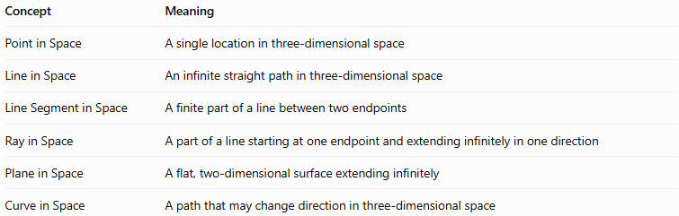
Concept | Meaning
Point in Space | A single location in three-dimensional space
Line in Space | An infinite straight path in three-dimensional space
Line Segment in Space | A finite part of a line between two endpoints
Ray in Space | A part of a line starting at one endpoint and extending infinitely in one direction
Plane in Space | A flat, two-dimensional surface extending infinitely
Curve in Space | A path that may change direction in three-dimensional space

Applications
# Source: AI Source: Provided by: [Data Path: Persons Table -> ID Column: 1, Name_En Column: Motasem Essam] -> From: [ChatGPT] on [7/25/2026]
- Coordinate geometry: Representing and calculating positions in 3D.
- Architecture: Modeling straight structural alignments and spatial directions.
- Engineering: Describing axes, shafts, beams, and straight trajectories.
- Computer graphics: Defining camera rays, object directions, and intersection tests.
- Physics: Modeling idealized straight-line motion.
- Robotics: Representing directions and paths in three-dimensional working spaces.

Key Points
# Source: AI Source: Provided by: [Data Path: Persons Table -> ID Column: 1, Name_En Column: Motasem Essam] -> From: [ChatGPT] on [7/25/2026]
- A line in space extends infinitely in both directions.
- A point and a nonzero direction vector determine a unique line.
- Two distinct points determine exactly one line.
- A line can be represented using vector, parametric, or symmetric equations.
- A line in space is not restricted to the coordinate planes.
- Two lines in space can be parallel, intersecting, skew, or coincident.
- A line is one-dimensional, whereas a plane is two-dimensional.

Conclusion
# Source: AI Source: Provided by: [Data Path: Persons Table -> ID Column: 1, Name_En Column: Motasem Essam] -> From: [ChatGPT] on [7/25/2026]
A line in space is a fundamental object in solid geometry that represents an infinite straight path in three-dimensional space. Its position and orientation can be described using coordinates, direction vectors, and equations. Understanding lines in space provides the foundation for studying line segments, rays, parallel and skew lines, and intersections between lines and planes.

